Main Title: [Times New Roman 18 bold]
Subtitle [Times New Roman 16]
YOUR NAME¹, CO-AUTHOR² [Times New Roman 12 capitals, followed by 1 blank line]

¹Institution, University, City, Country
²Other Institution, University, City, Country [Times New Roman 10, followed by 1 blank line]

1. INTRODUCTION [HEADING-Times New Roman 10pt bold capitals]
[Main Text: Times New Roman 10pt] These instructions apply to authors invited to submit a long paper. Invited long papers must be submitted electronically by June 4th, 2026. Authors must prepare their manuscript using the MS Word template provided by the conference organizers. Text shown in red within the template provides formatting guidance and layout instructions and must be deleted before submission. The purpose of the template is to ensure a consistent and uniform format for all submissions.
The invitation to submit a long paper is based on the selection of contributions for oral presentations and short oral presentations by the Scientific Committee. Long papers may be considered for publication in indexed journals associated with the PLEA Conference. Papers that are not selected for journal publication may be published in the Kerwá Institutional Repository of the University of Costa Rica, each with an individual DOI. Participation in this long paper submission process is optional, as all accepted contributions will have their extended abstracts published in the official Conference Proceedings book.
Authors are fully responsible for the content of their papers. Submissions must represent original work that has not been previously published and must not be under consideration for publication elsewhere. Authors are also responsible for obtaining any necessary permissions for the use of copyrighted materials, including images, figures, tables, or other reproduced content.

2. PREPARING THE MANUSCRIPT
With A4 paper size (210 × 297 mm), including illustrations, tables, and references, long papers should be limited to a maximum of 6000 words.
To layout your paper, please use this document as a template and follow these guidelines. Keep the text within the margins shown in this example. Leave one empty line before each section or subsection. There should be no empty line after the title of subsections; only an indentation should indicate the beginning of each paragraph. The text should be justified with single line spacing.
Section headings should be typed in capital letters, bold, and numbered. Subsections should be typed in upper and lower case, bold, and numbered.

2.1 Tracks and title [Subheading: Times New Roman 10pt bold, upper and lower case]
Submission should be present new, original research that focuses on one of the four tracks.
The title should be informative and concise. Avoid using acronyms in the title.

2.2 Citation and references
References should not appear as footnotes but should be gathered together at the end of the text. References should be numbered and cited like, [1], [2-3], [1,4], etc. Numbered references matches previous PLEA proceedings.

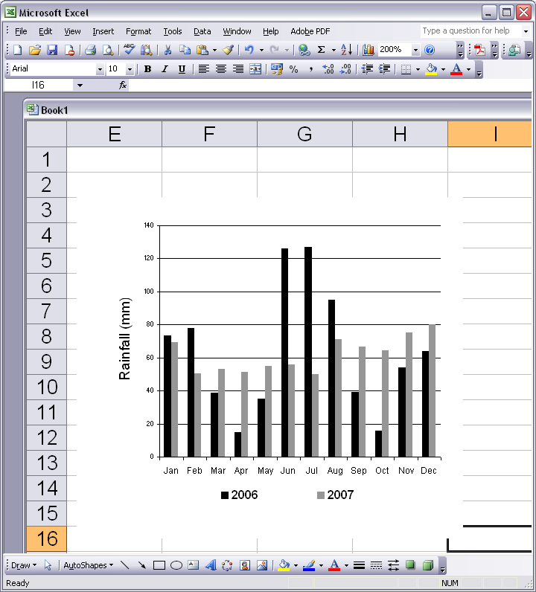
Figure 1: Clear line drawings are essential. [Times New Roman 9 italic]

2.3 Figures and tables
Drawings and graphs should not exceed 50% of the entire paper content and should be located close to their corresponding citation. Figures and photographs must carry numbers in the text (Fig. 1) and a caption. Captions should be complete enough to allow appreciation of the illustration without referring to the text. Lettering of the caption should be nearly as large as the typeface used for the text. Make sure that illustrations are clear and easy to read. Images and graphics can be colour, but must be legible in black and white for greyscale. For example, use different fill patterns or line styles/markers or contrasting shades, which can be more easily distinguished. (refer to in Fig. 1).
Tabular presentation of data is an easy way of condensing many items. Tables must also carry numbers in the text (Table 1).
Figures and tables may reside within a column or span both columns, but should be centred.

Table 1: Sky conditions probability for clear sky (ρ_{cs}), partly overcast sky (ρ_{ps}), and fully overcast sky (ρ_{os}). [Times Ney Roman 9 italic]

Month | ρ_{cs} (%) | ρ_{ps}(%) | ρ_{os}(%)
JAN | 5.88 | 36.88 | 57.24
FEB | 6.79 | 45.65 | 47.57
MAR | 5.48 | 40.40 | 54.12
APR | 16.39 | 51.58 | 32.03
MAY | 11.18 | 45.27 | 43.55
JUN | 12.87 | 33.68 | 53.45

2.4 Equations
Equations should be centered. They are numbered as (1), (2), etc. They are referred in the main texts as “Equation (n)”. Descriptions of the equation can start from the next line. For example like the following Equation (1):
PET = 1.2T_{a} - 2.2v + 0.55 (T_{mrt} – T_{a}) (1)
where PET - Physiological Equivalent Temperature (◦C);
T_{a} - air temperature (◦C);
T_{mrt} - mean radiant temperature (◦C);
v - air speed (m/s).

3. SUBMISSION INSTRUCTION
Please name your manuscript or create a file which begins with your Conftool Submission ID and includes the title of the long paper (i.e., 365-Main title.docx). Upload the long paper in .DOCX format.
Log in to the paper submission site at http://www.conftool.org/plea2026/.
Authors whose contributions have been selected for poster presentation may also upload their poster in PDF format as part of this submission call. Posters should be prepared using the official poster template available on the conference website and should clearly summarize the objectives, methodology, main findings, and relevance of the research.
Copyright consent: Should the long paper be accepted, the authors, represented by the submitting author will assign the organisers of PLEA 2026 the rights to use, distribute, publish, reproduce and archive the work.

4. CONCLUSION
This paper showed how to prepare and upload a good long paper for inclusion in the PLEA 2026 Conference. We hope to see you in Costa Rica!

ACKNOWLEDGEMENTS
This section, if included, appears right after the main body of the text and is headed “Acknowledgments.” This section includes acknowledgments of help received from associates and colleagues, credits to sponsoring agencies, financial support, and permission to publish.

REFERENCES
1. Igawa, N. and H. Nakamura, (2001). All Sky Model as a standard sky for the simulation of daylight environment. Building and Environment, 36: p. 763-770.
2. Kittler, R., (1985). Luminance distribution characteristics of homogeneous skies: a measurement and prediction strategy. Lighting Research and Technology, 17(4): p. 183-8.
3. Perraudeau, M., (1988). Luminance models. In National Lighting Conference. Cambridge, UK, March 27-30.
4. International Daylight Monitoring Programme, [Online], Available: http://idmp.entpe.fr/ [16 June 2008].

